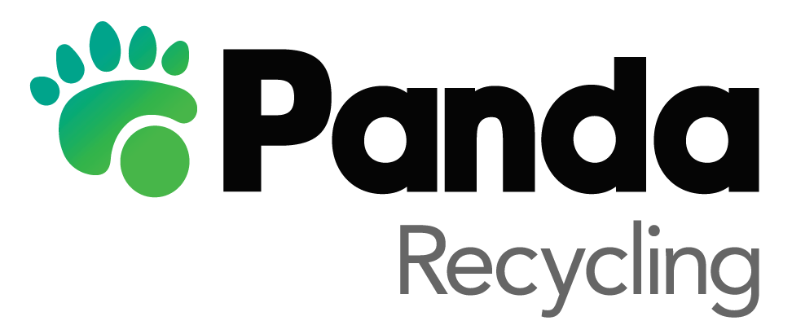

**Job Title**: Customer Service Representative   
**Location**: Millennium Business Park, Cappagh Road, Dublin 11  
**Reporting to**: Customer Service Supervisor

**Hours of Work**: 8am-6pm Monday to Friday (Shift rotation 45 hours)

9am-1pm (Rostered approx. 1 every 6 weeks)

Customer Service Representative - Excellent Communication Skills Required

Join our team at Panda Waste and utilise your exceptional communication skills to deliver outstanding customer service. No prior experience is needed, as we welcome quick learners who are eager to develop their skills in a dynamic and supportive environment.

As a vital part of our Customer Service team, you will act as a support to customers throughout their interactions with The Panda Group. Your exceptional communication skills will be essential in providing accurate information, resolving queries, and addressing customer concerns.

[Principal Accountabilities]

* Utilise your excellent communication skills to answer incoming calls and direct them to the appropriate personnel.
* Engage with customers, both commercial and residential, in a professional and courteous manner, ensuring their satisfaction.
* Demonstrate your knowledge and attention to detail by providing accurate and comprehensive information about our organisation and services.
* Address customer service queries and complaints, collaborating with other departments to ensure timely resolution.
* Process customer-related queries and requests efficiently and consistently.
* Thrive in a flexible, multi-skilled environment and contribute positively to the team.
* Utilise your communication skills to make outbound courtesy calls, following up on customer complaints.

[Skills Required]

* Quick learner with the ability to adapt and develop new skills in a fast-paced environment.
* Possess a professional and friendly telephone manner, engaging customers with empathy and courtesy.
* Strong knowledge retention ability to provide accurate and detailed information to customers.
* Attention to detail to ensure precise and thorough customer service.
* Customer-focused mindset, dedicated to meeting and exceeding customer expectations.
* Excellent organisational skills to manage tasks and prioritise effectively.
* Proficient computer skills to navigate customer service systems efficiently.
* Ability to work collaboratively in a team environment, fostering a positive and supportive atmosphere.
* Effective communication skills, both verbal and written, to ensure clear and concise interactions with customers.
* Demonstrated ability to perform under pressure and remain calm and composed.
* Flexibility to adapt to different tasks and responsibilities within the working environment.

Join our Panda Waste family, where the Irish spirit thrives alongside environmental stewardship. We are seeking individuals with excellent communication skills and a quick learning ability to deliver top-notch customer service. No prior experience is needed, as we provide comprehensive training and support. Explore our current opportunities and be part of a team that blends tradition, innovation, and sustainability to make a positive impact on our Emerald Isle.

###### Application Process

If you are interested in this position, please send your application to [Chelsea.whelan@panda.ie](mailto:Chelsea.whelan@panda.ie)

Closing date 04/05/2023